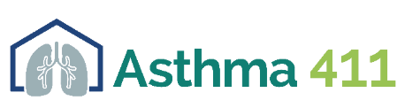
Breathe with Ease Art Contest: Consent Form
(Must be signed by contestant or parent/legal guardian, if contestant is under 18)

I understand that it is the contestant’s responsibility to secure all necessary resources for this contest. I further agree that all artwork will become property of Asthma 411 and UNTHSC. I have read and understand the contest rules and guidelines and agree to all terms within.

Contestants under age 18

I am the custodial parent or legal guardian of ________________________________ (contestant’s name). I give my consent for my son/daughter to participate in the Breathe with Ease Art Contest.

____________________________ __________________________ ___________________
Print Parent/Legal Guardian Name Signature Date

OR

Contestants age 18 and older

____________________________ ___________________________ ___________________
Contestant Name Signature Date

